Solar Workgroup of Southwest Virginia

Group Power Purchase RFI - Questions and Responses

May 4, 2020

Table of Contents

Regional Information/Background 1
Policy and Regulations 4
Project Development Cost Recovery and Development Fees 6
Characteristics and Selection of Participating Sites 8
Project Development Roles 10
Energy Storage 12
Miscellaneous 13

Regional Information/Background
1. What are the 7 coalfield counties?
The following areas are included in the RFI: Buchanan, Dickenson, Lee, Russell, Scott, Tazewell, Wise, and the City of Norton. This is the “coalfield” region of Southwest Virginia that the SWG targets with its work. Because of the region’s social and economic ties to neighboring Washington County, it is possible that we will pursue installations in Washington County, but it is not the focus of our work.

2. Does the SWG have a map of the seven counties in play and the utility territory associated with each?
See the map below. A full map of electric utility service territories is available here: https://scc.virginia.gov/getattachment/46ad3b08-b38f-4d1d-be3b-a224e246ec7c/el_map.pdf
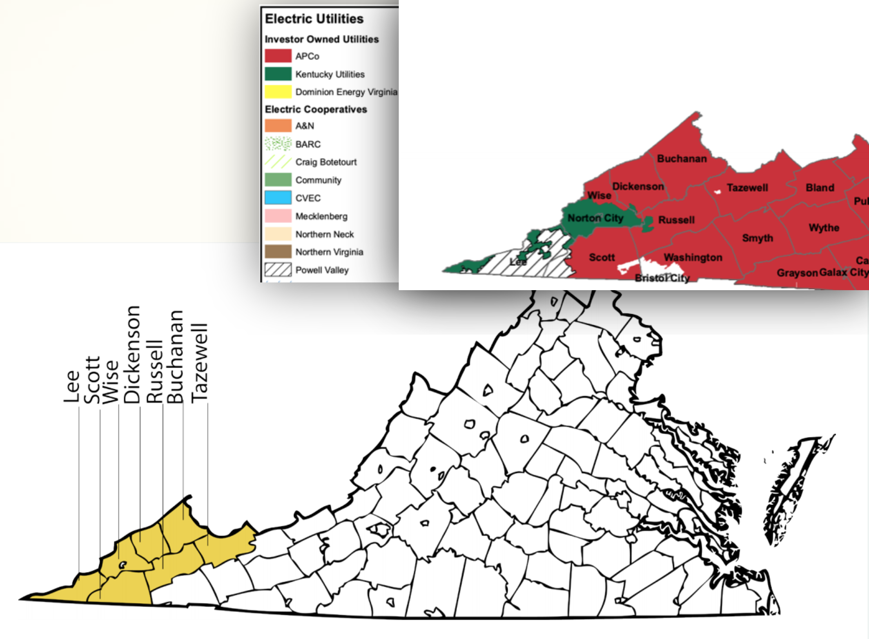

3. Do you have information on population or population density associated with the target area?
Approximate populations for the target area include:
- Buchanan County: 21,000
- Dickenson County: 14,500
- Lee County: 23,500
- Russell County: 26,700
- Scott County: 21,500
- Tazewell County: 40,900
- Wise County: 38,000
- Norton City: 4,000
Below is a population density map in the region as of 2010.
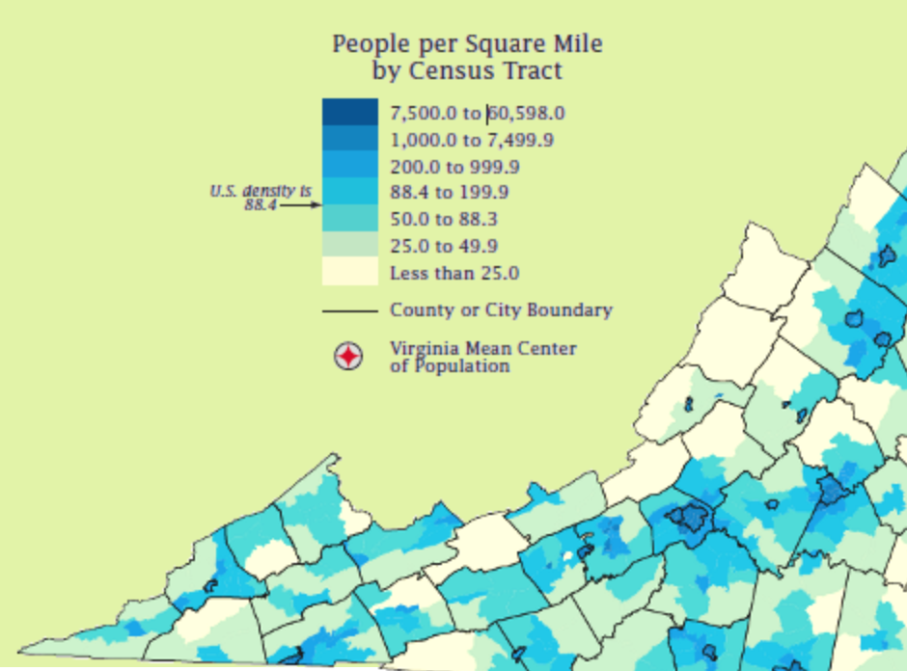

4. Which are the main towns where most of the commercial/industrial installations are expected to come from?
We don’t have an expectation of where most of the installations will be at this point, as it will be somewhat informed by the co-developer(s) expertise and experience. However, the most populous towns/cities in the region include Appalachia, Big Stone Gap, Bluefield, Cedar Bluff, Clintwood, Coeburn, Gate City, Honaker, Lebanon, Norton, Pennington Gap, Richlands, Tazewell, Weber City, and Wise.
5. Does the SWG have a sense of what capacity is sought to be generated in the region?

Not specifically, but we can offer the following numbers to help guide expectations.
- The economic analysis conducted in 2017 for the Solar Roadmap projected that 20.3 MW of commercial-scale solar could be installed in the region by 2027 (this assessment was completed prior to the passage of legislation to greatly expand renewable energy development in VA).
- There is a 40 MW cap on PPAs in ODP territory and a 40 MW cap on PPAs in APCo territory.
- The 6% net metering cap equates to approximately 14.4 MW of capacity in ODP territory and 240 MW of capacity in APCo territory.
- The Virginia Clean Economy Act requires Appalachian Power procure 600 MW of renewable energy by 2030. Additionally, by 2035, Dominion is required to procure 16,100 MW of solar or onshore wind located in Virginia, including 1,100 MW of solar ≤ 3 MW per individual project and 35 percent of such generating capacity procured shall be from solar facilities owned by persons other than a utility, including utility affiliates and deregulated affiliates. At least 200 MW of the 16,100 MW must be on previously developed project sites, including brownfields and coal-impacted lands. For all of this capacity, the projects do not have to be located in the utility’s service territory, so projects in Southwest Virginia can participate in either utility’s bidding opportunities.

Policy and Regulations
6. It is noted in Appendix A that APCo has yet to apply to the SCC pursuant to a 2017 for approval of a pilot community solar program. Does Appalachian Voices have any insight into the expected timing for community solar to be implemented in ApCo and ODP?

We do not have any insight on when community solar will be available in APCo territory. In ODP territory, the General Assembly approved a program to require ODP to allow community solar projects for multi-family housing. This program is expected to be available in the summer of 2021.

7. Are you aware of any mechanism which would require the utility to be the offtaker of energy produced in case of a host going out of business or ceasing operations?

No, we are not aware of any such mechanism. The impact of a host going out of business depends largely on who the owner of the building is and whether the electrical account remains open.

8. Are we correct in assessing that non-jurisdictional / public entities are not modified in the anticipated signed bill by the Governor?
The contracts in place for ODP and APCo non-jurisdictional (or public authority) customers are unaffected by the bills that were enacted in the 2020 session to increase the net metering cap and expand the PPA programs. However, our understanding is that non-jurisdictional customers that install net-metered systems will count toward the overall net metering caps, and non-jurisdictional customers that use PPAs will count toward the PPA caps. It is our hope that PPA and net metering limitations in contracts for non-jurisdictional customers will be lifted in the coming months. Both ODP and APCo have indicated that they are willing to renegotiate contracts with individual non-jurisdictional customers that are interested in installing solar projects.
9. Is there the potential to develop projects that allow for compensation closer to the residential rate to make brownfield solar projects more economic?

Solar projects that would be co-developed between SWG and the Co-Developer(s) will likely be compensated through net metering or at the wholesale/ avoided cost rate depending on the project size. We assume most projects will be financed through third-party PPAs, leases, or loans, and some may be partially offset with grants. Brownfields grants or USDA REAP grants may be used to lower project costs. In the coming years, projects will also begin to be compensated for RECs, which will bring compensation levels up. Currently, Virginia does not have a mechanism to compensate brownfields projects at a higher rate than non-brownfield projects.
10. Are design and permitting standards the same across all seven counties, or are there distinct nuances across each one?
Design and permitting standards across the seven counties are not identical. For the counties, Norton, and St. Paul that went through the SolSmart program, their solar procedures and requirements are available online here: https://swvasolar.org/local-government/. The requirements across the SolSmart jurisdictions are relatively similar. Interconnection requirements, and thus system design requirements, may vary across utility territories.
11. Our understanding is that VA has exempted solar projects from sales tax and personal property tax (under 5MW at least). Is that a safe assumption across the state?
Yes, that is correct.
House Bill 1305 (Chapter 346), provides an exemption from the Retail Sales and Use Tax for machinery, tools, and equipment used by a public service corporation to generate energy derived from sunlight and wind beginning January 1, 2017, and expiring June 30, 2027.
This Act also provides that the exemption from local property taxation for solar photovoltaic systems will apply in full only to:
- Projects equaling 20 MW or less, measured in alternating current (AC) generation capacity, for which an initial interconnection request form is filed with an electric utility or regional transmission organization on or before December 31, 2018;
- Projects equaling 20 MW or less that serve a public institute of higher education or a private college in the Commonwealth; and
- Projects equaling 5 MW or less for which an initial interconnection request form is filed on or after January 1, 2019.
This Act also provides that the exemption from local taxation for solar photovoltaic systems will apply to 80 percent of the assessed value for:
- Projects greater than 20 MW first in service on or after January 1, 2017 and for which an initial interconnection request form was filed after January 1, 2015; and
- Projects greater than 5 MW for which an initial interconnection request form is filed on or after January 1, 2019.
The Act also provides that the local exemption for solar photovoltaic projects greater than 20 MW will not apply to projects upon which construction begins after January 1, 2024.
Under current law, raw materials that are inputs to production of electricity, including fuel, used by a public service corporation are exempt from the Retail Sales and Use Tax. All other tangible personal property used by a public service corporation in the generation of electric power is subject to the Retail Sales and Use Tax. Currently, the local tax exemption for solar photovoltaic systems applies to projects equaling 20 MW or less, as measured in alternating current generation capacity.
For more information regarding sales and property tax exemptions in Virginia, see https://www.tax.virginia.gov/laws-rules-decisions/rulings-tax-commissioner/16-221#_Toc451862468

12. Is net metering the assumed offtake for the projects that are co-developed in the absence of community solar programs in SWVA?

For projects 3 MW or less, net metering arrangements are likely to be the most cost-effective option. Larger projects are not eligible for net metering. Developers might also consider undersizing projects to avoid excess generation, using energy storage to avoid excess generation, or taking the avoided cost rate for larger projects or projects that are not eligible for net metering.

Project Development Cost Recovery and Development Fees

13. Is the SWG looking for any success fees (developer fees or broker fees) based on successful development of projects?
No.
14. How are development costs anticipated to be covered on this initiative, such as preliminary designs, engineering, interconnection applications, etc?
We would like for the companies responding to the RFI to propose how to cover these costs. Typically, these costs are covered in the total installation cost and charged to the customer as part of the full cash-purchase or PPA package. The ultimate project installer will be responsible for initiating and completing interconnection applications. SWG Planning Team member paleBLUEdot can provide preliminary designs and design/build bid documents, which can help to weed out projects that may not ultimately be suitable solar projects, thus saving the co-developer some design and engineering costs. See examples of these documents from the SWG 2019 RFP online at: https://palebluedot.llc/solar-workgroup-of-southwest-virginia-group-solar-solicitation-2019

15. What is the thought behind structuring the compensation for Co-Development as a Developer Fee paid at financing?
  - Is there an assumption that the projects would be sold to a third-party owner that pays a Developer Fee or is SWG proposing to pay the Developer Fee?
At this time the SWG is not proposing to pay the Developer Fee. The assumption is that developer fees would be rolled into total project costs which are then covered either through a purchase agreement with the site (1st-party ownership structure) or through a 3rd-party ownership structure (like a PPA). Alternative options can be suggested by co-developer partners. It is possible that grant funds may become available to cover certain portions of the developer fee, though those would not be available until late 2020 under current proposals.

  - If the projects are developed for a third-party owner and the Co-Developer is dedicating internal resources to the project, would the Co-Developer be able to receive compensation in advance of financing?
Yes, assuming the final 3rd-party owner is open to that approach.

  - What does the SWG view as qualifying for “Financing” in the reference related to the Development Fee?
This is a question we are hoping to answer through the RFI process. We invite your suggestions in your response to the RFI. Financing included in the Development Fee can include whatever elements the co-developer proposes.

16. Will there be any budget provided for the “co-development partner” for activities such as “site concept development” and “financial pro forma development” Or are these assumed to be sunk costs born by the RFP winner for solar development?
Some tasks can be supported by the SWG team, including support in site identification, site feasibility assessment, site concept design development, and preliminary installation cost estimating in support of pro forma development. See example documents from the 2019 RFP (Exhibit A documents) online here: https://palebluedot.llc/solar-workgroup-of-southwest-virginia-group-solar-solicitation-2019
Other tasks such as pro forma development, financial modeling, and finance procurement will be needed by the co-development partner(s).
The SWG is assessing how those costs will be covered. One option we are evaluating is requesting that the co-developer roll them into their project development costs. The SWG has pursued and obtained grant funding in the past to cover those expenses, which remains an option we are willing to consider under the co-development agreement.
We seek feedback from potential co-development partners as to whether those expenses could be covered in overall development costs, or if additional funding (ie- grant or site-owner) sources would need to be secured to cover these expenses.

Characteristics and Selection of Participating Sites

17. How important is rooftop development to SWG’s goals?

It is not necessary that the projects be exclusively rooftop projects. We place a priority on helping anchor institutions (see below) go solar as they are important entities in the community that can help lead to more solar installations in the community. These are often rooftop sites, but not always. Many projects that have been considered to date are ground-mount systems.

18. Would the SWG consider selecting a partner that would only focus on brownfield development?

Yes, the SWG will consider partnering with a co-developer that would focus only on brownfield development; however, in that scenario, we would likely select more than one co-developer partner so that we could continue to provide development assistance to anchor institutions without brownfield sites.

19. Does SWG have any thoughts around standardizing equipment from a design, cost, or sanity perspective?
The appropriate equipment to be used for the installations is entirely dependent on the cohort of sites ultimately selected and the recommendations/preferences of the installer. The co-developer partner can propose to focus on a specific sector/type of projects in an effort to standardize equipment and designs so as to lower development costs, but this is not required.
20. Is the focus of the RFI and eventual RFP C&I projects, or will the portfolio contain any utility scale or residential projects?
The focus of this RFI is C&I projects, but the SWG is working to develop residential and utility-scale projects. If your firm has an interest in partnering with the SWG on residential- or utility-scale projects, please indicate this in your response. Note that we will be re-issuing our most recent residential Solarize RFP in the coming weeks.
21. Does the working group have pre-identified but yet unvetted sites or community partners not committed to other RFP/Solarize programs? Does the SWG currently have a full portfolio of potential projects or will it be developing them during the RFP performance period?

We have not identified specific projects for the forthcoming partnership, as we hope the RFI responses and co-developers will inform the types of entities that we target. We have several building/site owners who have expressed interest in solar, but have not committed to participating in the next RFP.

22. Is there a total number of MWs, # of sites, etc. goal that is in consideration here for this 6-18 month initiative?

Based on our past experiences with the first two RFPs, the SWG seeks a partnership arrangement that will result in the construction of at least 5-10 projects for a total of at least 1-3 MW over the 6-18 month initiative. This may be modified based on RFI responses.

23. What is the expected minimum and maximize size of the projects that would be co-developed?

We do not intend to place a specific minimum or maximum on the projects that will be co-developed except as agreed to with the ultimate co-development partner(s) selected. In other words, we have not set a limit at this time, but anticipate that we would set a target size range with the co-development partner(s). Project size range will depend on RFI responses and co-developer focus areas. To date, the SWG has worked with site owners that have projects in the 5 kW - 2 MW range.

24. Can you give us any examples, even broadly, of the types of “anchor projects” (or projects in general) that the SWG has in mind?
Given policy limitations, the utility service territories will mostly likely focus on Old Dominion Power and Appalachian Power territories, but may also include projects in Richlands, BVU, and Powell Valley Electric Cooperative.
Anchor institutions include schools, colleges and universities, local government buildings, hospitals, downtown businesses, and community nonprofits such as Mountain Empire Older Citizens, People Incorporated, Appalachian Community Action Agency and Development Agency. The Solar Roadmap published in 2017 included a list of possible projects, some of which were included in the first RFP issued by the SWG. The full list is included below for easy reference:
- Food City Grocery Stores
- Norton Green Apartments (RFP #1, no contract signed)
- Jonesville Manor
- Deskins Apartment Complex
- Powell Valley National Bank
- Ridgeview High School (RFP #1, contract pending)
- Mutual Drugstore
- Lonesome Pine Regional Technology and Business Park (RFP #1, no contract signed)
- Eastside High School and Coeburn Primary
- Mountain View Regional Medical Center
- Lonesome Pine Hospital
- UVa-Wise
- Southwest Virginia Community College
- Mountain Empire Community College
- Central High School – Wise, VA (RFP #1, contract pending)
25. Will the sites that were scoped during the 2019 RFP but not executed be available for this program?

The selected developers for both of the RFPs are still pursuing financing and installation for some of the projects, but other projects are no longer being pursued. For those projects that are no longer being pursued by the selected developer, the site owners will be given the option to participate in future RFPs.

26. Would you be able to share indicative utility bills or utility tariffs for the load users you expect would be a fit for this program?

Links to utility tariff sheets for the utilities can be found in RFI Appendix B: http://swvasolar.org/wp-content/uploads/2020/04/Appendix-B_-Rate-Design-in-SWVA-Final.pdf

Bills for the sites included in the second RFP can be found at https://palebluedot.llc/swg-2019-electric-use

Please email Chelsea Barnes at chelsea@appvoices.org to request a password to access the documents.

27. Is SWG willing to jointly with the co-developer a minimum target in terms of aggregate capacity that will justify the project?

Yes. If you are able, we ask that you include a suggested minimum target in your RFI response to better inform the RFP. The installer/developer could also establish individual project costs on a project by project basis and then introduce a sliding scale discount based on success at hitting milestones within the campaign.

Project Development Roles

28. Would the Co-Developer partner(s) be allowed to build and/or own the projects long-term?

Yes. Note that presumably we would want to continue to try to offer both a cash-purchase option in addition to financing options, but that we assume most site owners will not be able to participate through a cash-purchase.

29. Would the Co-Developer partner(s) have the opportunity to be the financing entity and equity owner in the projects that are co-developed?

Yes. Note that presumably we will try to offer both a cash-purchase option in addition to financing options, but that we assume most site owners will not be able to participate through a cash-purchase.

30. If applicable and available, can Appalachian Voices provide information on the electric rates paid by potential net metering customers for financial pro forma modeling?

Once sites are identified, the SWG will work with site owners to obtain relevant tariffs and electricity bills.

Links to utility tariff sheets for the utilities can be found in RFI Appendix B: http://swvasolar.org/wp-content/uploads/2020/04/Appendix-B_-Rate-Design-in-SWVA-Final.pdf

Electric utility bills for the sites included in the second RFP can be found at https://palebluedot.llc/swg-2019-electric-use. Please email Chelsea Barnes at chelsea@appvoices.org to request a password to access these documents.

Pro forma modeling developed by paleBLUEdot for the second RFP can be found at https://palebluedot.llc/solar-workgroup-of-southwest-virginia-group-solar-solicitation-2019

31. What role does Appalachian Voices plan to have in the Site Identification process?

To date, the SWG has played a leading role in identifying sites, with Appalachian Voices providing significant staff capacity in support of the process, along with other meaningful contributions from other SWG partners. We have called our partners at local governments, issued press releases, and used social media to find interested site owners. We assume we will continue to play a major role in site identification, but envision that we will refine our outreach focus based on the selected co-development partner’s areas of expertise.

32. What is the extent of Appalachian Voices’ technical/engineering and legal resources (if applicable) to assist with site identification and site control agreements?

paleBLUEdot participates on the SWG planning team and provides site feasibility assessments and concept designs. paleBLUEdot can also support the development of preliminary installation cost estimates in support of the development pro-forma. This role has been to provide a baseline reference in the initial stages of the RFP process, and should not be relied on for final system design. See examples of these documents from the 2019 RFP online here: https://palebluedot.llc/solar-workgroup-of-southwest-virginia-group-solar-solicitation-2019 (See Exhibit A documents).

Documents that can be produced through this contribution can support competitive design/build installer bidding or be used to initiate detailed engineering by a third party prior to installer bidding. paleBLUEdot’s role has been supported by grant and voucher programs, along with in-kind contributions of time. Beyond this contribution, the SWG does not have engineering expertise or staff.

Southern Environmental Law Center provides the SWG planning team with policy and legal analysis, but does not offer legal support to site owners or the SWG for site control agreements. SELC’s involvement in the SWG is supported through in-kind contributions of time.

33. Does the SWG expect any local solar developer/EPCs to respond to this and does it plan to, or is it open to or does it plan on playing “matchmaker” between such EPCs and financial partners?
This is an open question we are trying to answer through the RFI process, and welcome your company’s suggestions/preferences. We are not yet sure whether any local developers or EPCs will respond. We are open to connecting EPCs, developers, and financial partners together as needed and based on RFI responses. We anticipate that this will be required.
34. Is there a possibility for this co-developer to be the sole EPC/installer of systems?

Yes, that is possible. The ultimate co-developer arrangement depends on the RFI responses and the ultimate RFP arrangement.

Energy Storage

35. Will Appalachian Voices include in the SWG site selection criteria the potential for the addition of storage at a later date if it cannot be paired immediately to a PV system?

Yes. For some projects, battery storage is a cost-effective solution because it can help electricity customers avoid high demand charges, but we understand that battery storage is not often a cost-effective investment for most Virginia customers at this time.

36. Is the co-developer selected expected to also have expertise in storage?
We do not require that the co-development partner have energy storage expertise, but hope to find at least one partner that can help use storage as a solution for customers with high demand charges.

37. In the Solar Roadmap published by SWG in 2017 the feasibility of adding pump storage was considered. What does this mean in terms of site selection?

The pump storage reference in the Solar Roadmap was primarily referencing a utility-scale pump storage project being pursued by Dominion Energy. We have not considered smaller-scale pump storage projects in our Group Purchase Program to date, and have not prioritized exploring those options. We are aware of a recently announced program that is exploring possibilities of smaller-scale pump storage projects combined with industrial sites in Southwest Virginia and would be open to assessing opportunities associated with this project, though it should be noted this is outside the scope of our current planning.

Miscellaneous

38. Knowing that Dominion can source its renewable generation outside of its service territory, do you have any expertise into that procurement?

Dominion and APCo are required to issue RFPs at least once per year to meet their renewable energy procurement requirements. We do not yet know the planned timing of these RFPS, or whether they will be at regular planned intervals. SELC and Appalachian Voices will monitor State Corporation Commission proceedings to follow the process so projects in our region can participate to the fullest extent possible. We also have contacts at both utilities that we can connect you to.

