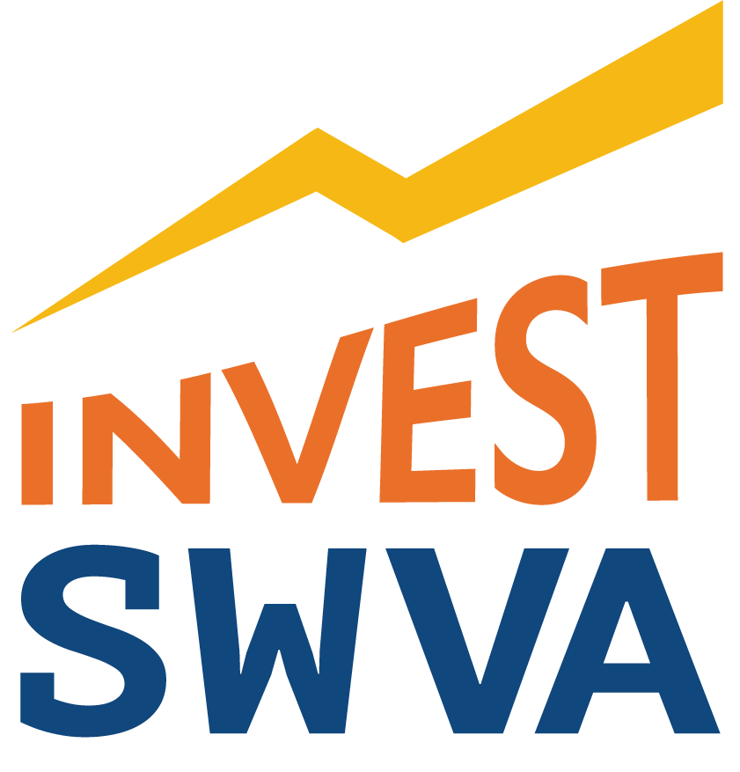

FOR IMMEDIATE RELEASE
April 30, 2020

Contact: Will Payne
Email: Will.Payne@CoalfieldLLC.com
Phone: 804-393-8380

Southwest Virginia Energy Innovation Projects
Advance to GO Virginia State Board

~ Projects Energizer, Innovation aim to ‘reinvent’ energy in Southwest Virginia ~

Duffield, VA — Two innovative energy projects from Southwest Virginia are headed to the GO Virginia State Board for its approval in June. The GO Virginia Region One Council approved Per Capital funding recommendations for Project Energizer and Project Innovation at its April 28, 2020 meeting.

“Projects Energizer and Innovation are about reinventing energy in Southwest Virginia — how we produce it and how we use it,” said Will Payne, Managing Partner of Coalfield Strategies, an economic development firm spearheading InvestSWVA. “We can do this in a way that attracts new business investment and defines the region as a hotbed for energy innovation.”

Launched in September 2019, InvestSWVA is a marketing campaign focused on energy innovation and the “future of work” in Southwest Virginia — attracting and retaining young talent by focusing on high-tech and high-wage jobs, a key GO Virginia Region One priority. This public-private regional marketing initiative led by Coalfield Strategies is funded by the Virginia Tobacco Region Revitalization Commission, Point Broadband, LENOWISCO Planning District Commission and American Electric Power.

Project Energizer, approved at $50,000, lays the foundation for a base load, renewable energy solution for high-tech and industrial applications, when coupled with other renewable power sources like wind and solar. Pumped-storage hydro is the only available proven, long-term power storage technology. This project employs this technology on a small, affordable scale and provides an opportunity for GO Virginia Region One to leverage its topography and be an innovator in renewable resources.

Project Innovation, approved at $100,000, will connect research, education and economic development in order to drive energy innovation, a GO Virginia Region One priority. The Southwest Virginia Energy Park, a first-of-its-kind operation in the United States, will host companies interested in studying, perfecting and eventually commercializing their ideas. The Energy Park will provide land, labs and scientific assistance to innovators in the energy industry. The project focuses on two broad areas: location vetting for research activities and a governance model that ensures long-term sustainability. Southwest Virginia will benefit from these activities as the Energy Park provides assistance in commercialization to the private sector, a key value-add that will encourage investment in and attract new industries and jobs to the region.

The InvestSWVA team is partnering with the LENOWISCO Planning District Commission (LENOWISCO) for both projects. LENOWISCO serves the Counties of Lee, Scott, and Wise, and the City of Norton.

“Projects Energizer and Innovation are about building on our region’s long history of energy production in order to grow our economy,” said Duane Miller, Executive Director of LENOWISCO. “By taking an all-the-above approach, Southwest Virginia has the opportunity to be the energy innovation capital of the East Coast.”

The GO Virginia Region One Council’s Growth and Diversification Plan states a commitment to pursuing alternative energy as a source of employment growth as well as building an ecosystem that encourages innovation. Both projects leverage the region’s unique geography, topography and land availability from reclaimed surface mining in order to revolutionize how we produce energy.

“The Region One Council was excited to approve these innovative approaches to diversifying the region’s economy,” said Mike Quillen, Chair of the GO Virginia Region One Council. “Southwest Virginia is a prime location for energy research and development activities that leverage our region’s talent and natural resources for job-creating projects.”

Other project partners providing expertise and funding include the U.S. Department of Energy, Liberty University School of Engineering and the Virginia Department of Mines, Minerals and Energy.

In addition, the Southwest Virginia Energy Research and Development Authority (Authority) is playing a key role. This public body was created during the 2019 General Assembly session by Senator Ben Chafin (R - Russell) and Delegate Terry Kilgore (R - Scott). The Authority’s purpose is to promote opportunities for energy development in Southwest Virginia, create jobs and economic activity in the region consistent with the Virginia Energy Plan, and position Southwest Virginia and the Commonwealth as a leader in energy workforce and energy technology research and development.

Project Energizer and Innovation build on InvestSWVA’s Project Oasis, which is identifying and studying data center opportunities across GO Virginia Region One, particularly on previously mined land, and is funded in part by a GO Virginia grant that was announced on August 6, 2019. The purpose of the project is to provide third-party validation for Region One to become the location of choice in the Commonwealth for data centers based on power and broadband infrastructure as well as the use of innovative energy applications. DMME is playing a strategic role in studying the use of 52-degree mine pool water for HVAC cooling as a significant cost and energy-saving tool.

The Project Energizer and Innovation proposals will be submitted to the Virginia Department of Housing and Community Development (DHCD), the support organization for the GO Virginia State Board, for evaluation and administrative approval. If approved by DHCD, the GO Virginia State Board will review the proposal at its June 23, 2020 meeting.

###

